**ECCE paper potential references**

[1] J. Wang, Y. Li, and Y. Han, “Evaluation and design for an integrated modular motor drive (IMMD) with GaN devices,” *2013 IEEE Energy Convers. Congr. Expo. ECCE 2013*, no. Immd, pp. 4318–4325, 2013.

Series connected

Active voltage balancer

Interleaving yapmış, akım ripple ı % 35 düşürmüş. Cap size düştü diyor ama nasıl?

[1] J. Wang and Y. Han, “A new concept of multilevel converter motor drive with modular design and split winding machine,” in *2014 Power and Energy Conference at Illinois (PECI)*, 2014, pp. 1–6.

Series connected

Balance lazım diyor ama devam etmiyor

dq set değerleri ile oyna

[1] N. R. Brown, T. M. Jahns, and R. D. Lorenz, “Power Converter Design for an Integrated Modular Motor Drive,” *Ind. Appl. Conf. 2007. 42nd IAS Annu. Meet. Conf. Rec. 2007 IEEE*, pp. 1322–1328, 2007.

5 phase-half bridge-common dc link

Two candidate IMMD dc bus architectures:

Inductance distribution figüre

simulation results- comparison of architectures

oscillations

experiment-both

[1] A. Gkountaras, C. Dinca, A. Giedymin, P. Birgel, U. Schaefer, and S. Dieckerhoff, “Low cost integrated motor-controller drive for an electrical active suspension system,” in *2014 16th European Conference on Power Electronics and Applications, EPE-ECCE Europe 2014*, 2014.

power ve communication inductance tan bahsediyor

[1] J. Wang, Y. Li, and Y. Han, “Integrated Modular Motor Drive Design With <roman>GaN</roman> Power <roman>FETs</roman>,” *IEEE Trans. Ind. Appl.*, vol. 51, no. 4, pp. 3198–3207, Jul. 2015.

Loop inductance çıkarmış (power, driver, coupling)

Ron etkisini incelemiş ve Lloop ile Ron’u birlikte düşünmüş (overshoot için)

Interleaving yapmış (seri)- Cap size düştü diyor ama nasıl?

%1 ripple sağlamak lazım diyor, ana nerde?

They will be synthesized, and the ripples tend to get diminished by each other, resulting in smaller total dc-link voltage ripple amplitude => yanlış, zaten göstermemiş (akımda göstermiş, voltajdaki böyle olur demiş, ama olmaz)

[1] G. Su and L. Tang, “A segmented traction drive system with a small dc bus capacitor,” in *2012 IEEE Energy Conversion Congress and Exposition (ECCE)*, 2012, pp. 2847–2853.

interleaving ile DC link ripple current düşürme (parallel bağlıda)

[1] Yehui Han, “Design, modeling, and control of multilevel converter motor drive with modular design and split winding machine,” in *2014 IEEE 15th Workshop on Control and Modeling for Power Electronics (COMPEL)*, 2014, vol. 203, pp. 1–10.

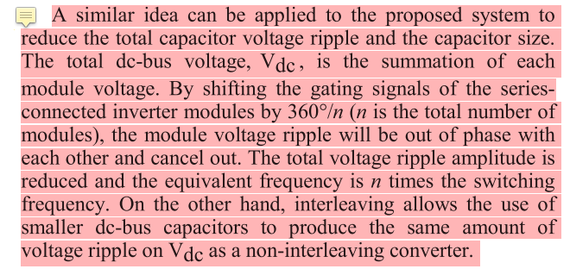

active voltage balancer

seri bağlıda interleaving ile dc link akım ripple ını düşürmüş

H. Zhang, L. Jin, O. Wallmark, and S. Norrga, “Evaluation of Modular Integrated Electric Drive Concepts for Automotive Traction Applications,” IEEE Transactions on Transportation Electrification, 2017.

stacked polyphaser bridge (SPB) => series (lv semiconductor, GaN), balance lazım

parallel-connected polyphase bridge (PPB)

Modülerlik => fault tolerance, small dc link capacitor

PPB-1: faz modüler

PPB-2: 3-faz modüler: bunda interleaving ile cap minimize edilebiliyor